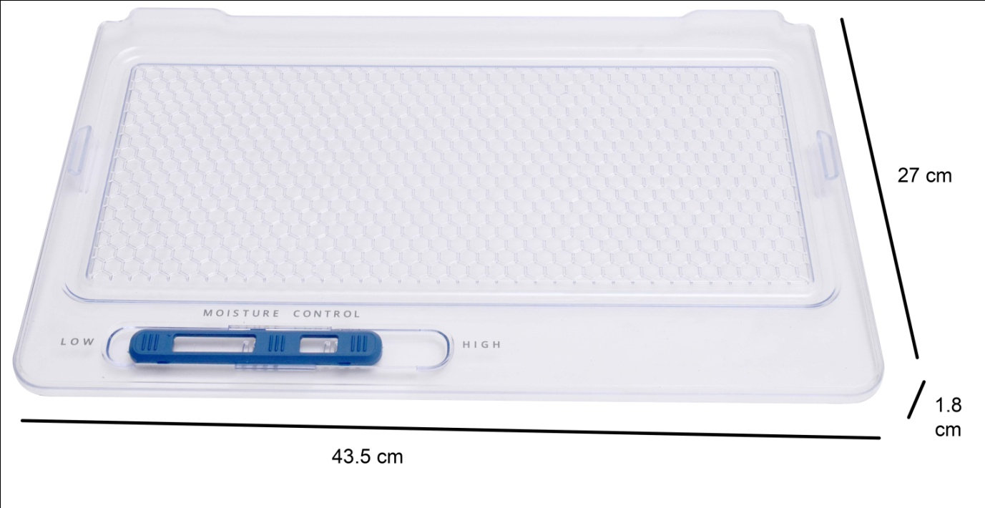
USED IN | REFRIGERATOR
SUITABLE BRAND | Whirlpool SINGLE DOOR REFRIGERATOR
REFRIGERATOR TYPE | SINGLE DOOR (MEAN ONLY ONE DOOR IN ENTIRE FRIDGE )
COMPATIBLE MODELS | Gen y/Ice magic/Imfresh (165 -210 litre only)
PART NO. | W10581294
DOES SUIT ALL whirlpool SINGLE DOOR | YES ONLY IN SINGLE DOOR
WHERE TO CHECK PART NO | IT MENSION OF TOP LEFT SIDE OF VEGETABLE BOX COVER.

NOTE: YOUR PRODUCT IMAGE MUST BE SAME AS THIS LISTED PRODUCT IMAGES ONLY THEN IT IS SUITABLE.

